**Lesson3: ICP3**

**NAME: BALA RISHIK**

**STUDENT ID: 700746746**

**GITHUB LINK:** [**https://github.com/BalaRishik001/Neural-Networks-and-Deep-Learning-Assignments**](https://github.com/BalaRishik001/Neural-Networks-and-Deep-Learning-Assignments) **VIDEO LINK:** [**https://drive.google.com/file/d/1yJHpV-jKtqv02Yz3h7JVheYl8tIXEXo_/view?usp=drive_link**](https://drive.google.com/file/d/1yJHpV-jKtqv02Yz3h7JVheYl8tIXEXo_/view?usp=drive_link)

**In class programming:**

1. **Create a class Employee and then do the following** 
   * Create a data member to count the number of Employees
   * Create a constructor to initialize name, family, salary, department
   * Create a function to average salary
   * Create a Fulltime Employee class and it should inherit the properties of Employee class
   * Create the instances of Fulltime Employee class and Employee class and call their member functions.

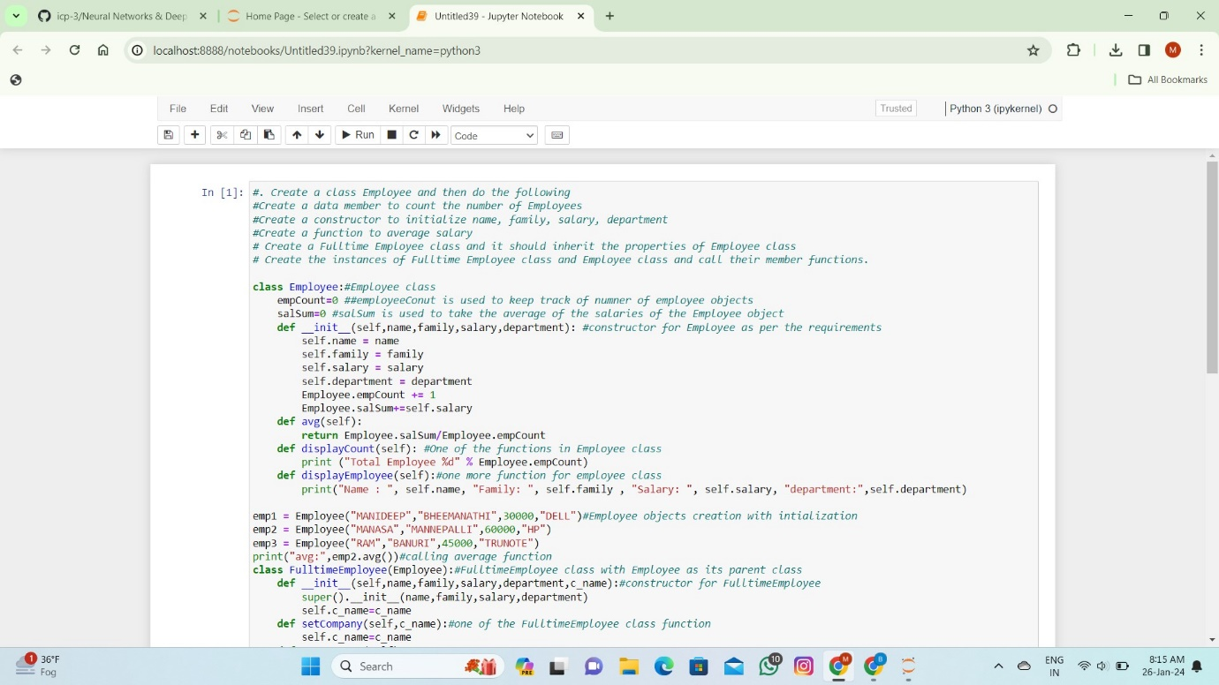

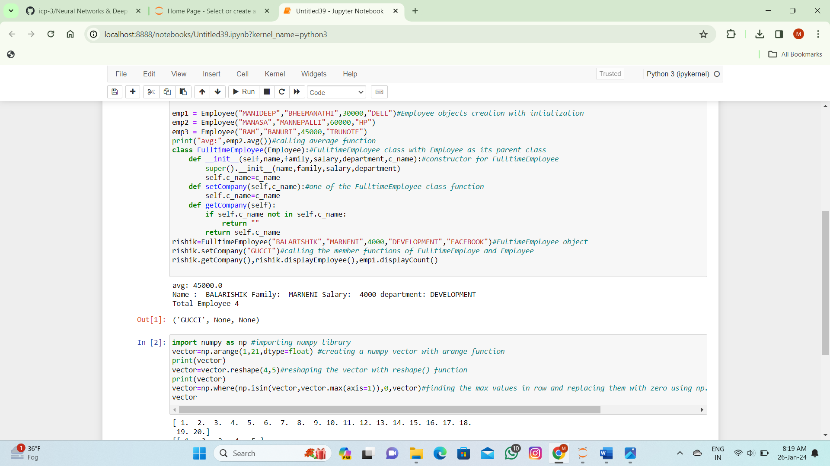

1. **Numpy**

Using NumPy create random vector of size 20 having only float in the range 1-20.

Then reshape the array to 4 by 5

Then replace the max in each row by 0 (axis=1)

(you can NOT implement it via for loop)

